EX.NO: 1.C WINDOWS FUNDAMENTALS ROLL NO : 231901027

DATE : 05.02.2025

AIM:

Windows fundamentals,learn about the built-in Microsoft tools the help keepthe device secure,such as windows updates,windows security,bitlocker and more

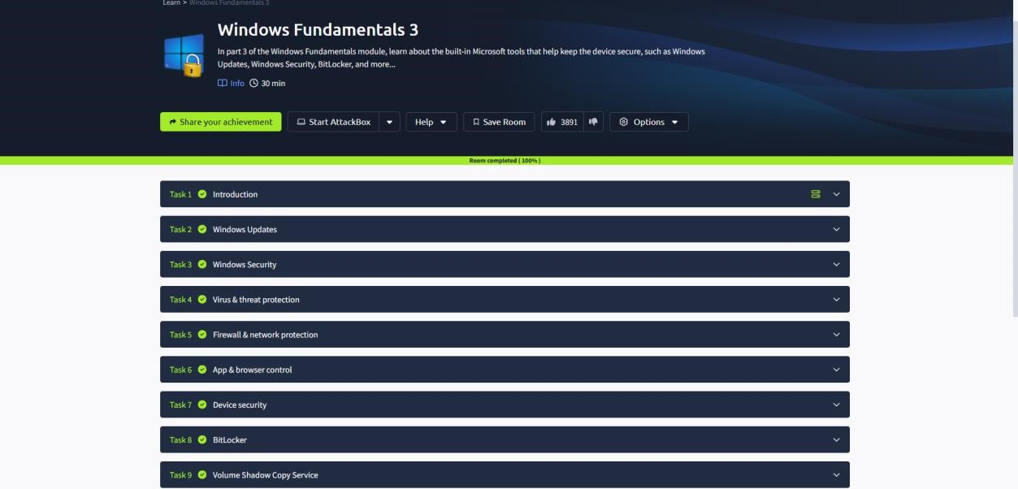

TASK 2 : WINDOWS UPDATES

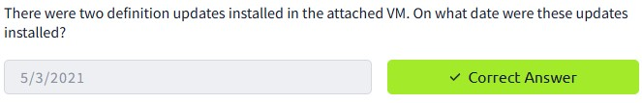

TASK 3 : WINDOWS SECURITY

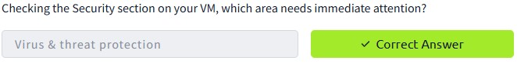

TASK 4 : VIRUS AND THREAT PROTECTION

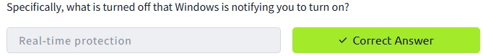

TASK 5 : FIREWALL AND NETWORK PROTECTION

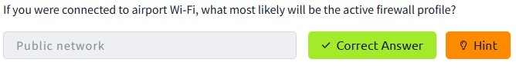

TASK 6 : APP AND BROWSER CONTROL

TASK 7 : DEVICE SECURITY

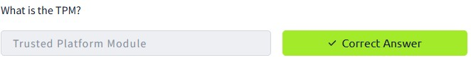

TASK 8 : BITLOCKER

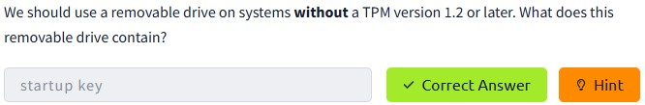

TASK 9 : VOLUME SHADOWS COPY SERVICE

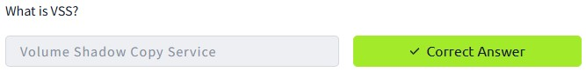

Conclusion:

Tryhackme platform windows fundamentals 3 task is successfully completed